ACROPOLIS INSTITUTE OF TECHNOLOGY AND RESEARCH
Department of IT, CSE(DS)
Synopsis
On
Real-Time Student Engagement Monitoring Dashboard

- Introduction
  - Problem Context (Real-world scenario)
In the education technology (EdTech) domain, existing learning management systems and virtual classroom platforms primarily focus on content delivery rather than measuring student engagement. Platforms such as video conferencing tools and e-learning systems can track attendance or login activity, but they lack the ability to assess whether a student is actively paying attention or meaningfully participating.
For example, a student may remain logged into an online session while being distracted by other activities, and the system would still mark them as “present.” Similarly, instructors handling large batches of students cannot manually monitor individual engagement levels during live sessions. This creates a gap between student presence and actual involvement, which directly impacts learning effectiveness.
Furthermore, most current solutions do not provide real-time analytics or actionable insights that educators can use during a session. The absence of such tools limits the ability to intervene when students lose focus. As a result, institutions struggle to maintain consistent engagement levels, leading to reduced knowledge retention and lower academic performance.

  - Motivation & Need
With the rapid growth of online and hybrid education, ensuring student engagement has become increasingly important. While several digital learning platforms are widely used, most of them are designed primarily for content delivery, assignment management, and communication, rather than active engagement monitoring.
Current solutions typically rely on basic indicators such as attendance, login duration, or assignment submission to measure participation. However, these metrics do not accurately reflect a student’s level of attention or involvement during a learning session. A student may be logged in for the entire duration of a class but remain distracted or inactive, making such measurements unreliable.
Additionally, existing platforms lack real-time feedback mechanisms that allow educators to identify disengagement as it occurs. Without timely insights, instructors are unable to take corrective actions during the session. Most systems also do not provide detailed analytics or visualizations that can help in understanding engagement patterns over time.
Therefore, there is a clear need for a more intelligent and responsive system that can monitor student engagement in real time and provide meaningful insights. Such a solution would bridge the gap between passive participation and active learning, ultimately enhancing the effectiveness of digital education.
- Literature Survey
Various research efforts and existing solutions in the EdTech domain have attempted to address the challenge of monitoring student engagement using different techniques.
Several research papers have explored computer vision-based approaches for engagement detection. For instance, studies on facial expression analysis and eye gaze tracking using libraries like OpenCV and deep learning models such as Convolutional Neural Networks (CNNs) have shown promising results in identifying attention levels. Other works focus on multimodal learning analytics, combining visual cues with interaction data to improve accuracy. However, these approaches often require high computational power and may raise privacy concerns.
In terms of existing applications, platforms like Zoom, Google Classroom, and Microsoft Teams are widely used in online education. While these tools support communication, attendance tracking, and content sharing, they lack built-in mechanisms to measure real-time student engagement. Some advanced tools like ClassDojo and Kahoot! attempt to increase interaction through gamification, but they still do not provide continuous engagement monitoring during sessions.
Currently, technologies used in this domain include computer vision (OpenCV), machine learning models (such as CNNs and classification algorithms), and data analytics tools for visualization. Frontend technologies like React and visualization libraries such as Chart.js are commonly used to build interactive dashboards, while backend frameworks like Flask or Node.js handle real-time data processing.
Despite these developments, existing systems either focus on engagement indirectly through participation metrics or require complex setups that are not feasible for all educational institutions. There remains a gap for a lightweight, real-time system that combines engagement detection with intuitive visualization, which this project aims to address.
  - Problem Statement
Current online and hybrid learning platforms are unable to accurately measure student engagement in real time. Existing systems rely on indirect indicators such as login status, attendance, or participation in activities, which do not reliably reflect actual attentiveness.
The problem is to design and develop a system that can monitor and quantify student engagement during live sessions using measurable parameters such as user activity or visual cues, and present this data through a real-time dashboard. The system should be capable of identifying varying levels of engagement (e.g., engaged, distracted, inactive) and updating these metrics continuously with minimal delay.
- Proposed Solution Overview
The proposed system, Real-Time Student Engagement Monitoring Dashboard, is designed to monitor and analyse student engagement during live or recorded learning sessions and present the results in an interactive dashboard for educators.
The system collects input data from student interaction sources such as webcam feeds (optional) or user activity patterns like mouse movement, keyboard usage, and response behaviour during learning sessions. This data is processed in real time using machine learning or rule-based techniques to classify engagement levels into categories such as engaged, moderately engaged, and disengaged.
The processed results are transmitted to a backend system, where they are aggregated and stored for analysis. A frontend dashboard visualizes this information using charts, graphs, and real-time indicators, enabling instructors to quickly understand overall class engagement and individual student behaviour.
The solution is designed to be lightweight, scalable, and adaptable to different learning environments, making it suitable for both online and hybrid classrooms.

- Objectives

The primary objectives of the proposed system are:
1. To design and develop a system capable of capturing student interaction or behavioural data during learning sessions in real time.
2. To implement a mechanism for analysing collected data and classifying student engagement into defined categories such as engaged, moderately engaged, and disengaged.
3. To build a real-time dashboard that visually represents student engagement levels using charts, graphs, and live indicators.
4. To ensure timely processing and updating of engagement metrics with minimal delay for effective monitoring during sessions.
5. To evaluate system performance based on accuracy of engagement classification and usability of the dashboard for educators.
- Contributions
The proposed system contributes to the field of educational technology by integrating real-time engagement monitoring with an interactive visualization dashboard in a lightweight and practical manner.
Key contributions of the project include:
1.A real-time framework for monitoring student engagement during live learning sessions using behavioural or interaction-based data.
2.A simplified engagement classification approach that categorizes students into multiple engagement levels without relying on overly complex infrastructure.
3.An interactive dashboard that provides instant visual feedback to educators, enabling quick identification of disengaged students.
4.A modular and scalable system design that can be adapted to different educational environments, including online, hybrid, and smart classroom setups.
5.A focus on combining data processing and visualization in a unified system, rather than treating engagement detection and reporting as separate components.
- Theoretical Analysis
6.1 Block Diagram
The block diagram of the proposed system illustrates the overall workflow of the Real-Time Student Engagement Monitoring Dashboard. The system is divided into four main components: data input, processing unit, storage layer, and visualization dashboard.
1. Input Module:
This module collects raw data from students during learning sessions. The input may include webcam feed (for facial expressions and atten2tion tracking) or interaction data such as mouse movement, keyboard activity, and response patterns.
2. Processing Unit:
The collected data is processed using machine learning algorithms or rule-based logic to analyze student behavior. Based on predefined parameters, the system classifies engagement levels such as engaged, moderately engaged, or disengaged.
3. Backend & Storage:
The processed results are sent to the backend server, where they are stored in a database. This allows tracking of engagement history and supports real-time data updates.
4. Dashboard / Output Module:
The final output is displayed on an interactive dashboard. It presents engagement data using charts, graphs, and live indicators, enabling educators to monitor student attention in real time.

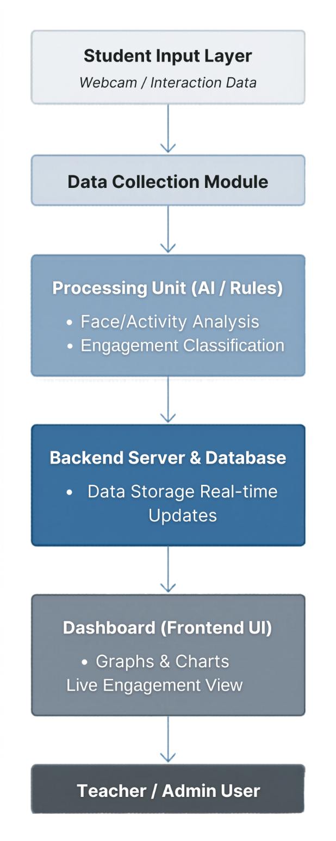

6.2 Hardware/Software Designing
- Hardware Requirements
- Processor: Intel i3 or higher (i5 recommended for smoother processing)
- RAM: Minimum 4 GB (8 GB preferred for real-time processing tasks)
- Storage: At least 10 GB free space for datasets, logs, and project files
- Webcam (optional): Required only if facial/visual engagement tracking is implemented
- Internet Connection: Required for real-time dashboard updates (if cloud database is used)

- Applications
The proposed Real-Time Student Engagement Monitoring Dashboard can be applied in the following areas:
- Online Learning Platforms
Used in virtual classrooms to monitor student engagement during live lectures and recorded sessions, helping instructors identify attention levels in real time.
- Hybrid Classrooms
Applicable in environments where both in-person and online students are present, enabling teachers to track engagement uniformly across both modes.
- Educational Institutions (Colleges & Universities)
Helps faculty members analyse student participation patterns and improve teaching effectiveness in large classrooms where individual monitoring is difficult.
- E-Learning Platforms and EdTech Systems
Can be integrated into learning management systems to enhance analytics by adding engagement-based insights beyond attendance and completion tracking.
- Corporate Training Programs
Useful in employee training sessions to evaluate attentiveness and participation during workshops, webinars, or skill development programs.
- Self-Paced Learning Systems
Can assist in understanding learner behavior patterns in self-learning environments by analyzing interaction data and progress consistency.

REFERENCES
- OpenCV Official Documentation
Reference for computer vision concepts, face detection, and image processing techniques.
- Scikit-learn Documentation
Used for understanding machine learning classification methods and data analysis techniques.
- TensorFlow Documentation
Reference for AI and deep learning concepts related to engagement detection.
- Flask Documentation
Used for backend framework concepts and API integration.
- Firebase Documentation
Reference for real-time database and cloud integration.
- Chart.js Documentation
Used for dashboard visualization and graphical representation techniques.
- Google Classroom
Studied as an example of an existing online learning management platform.
- Zoom Video Communications
Referenced for understanding online classroom interaction environments.
- Microsoft Teams
Studied for virtual classroom collaboration and participation systems.
- IEEE Xplore Digital Library
Research papers related to student engagement monitoring, learning analytics, and machine learning applications in education.
- Elsevier / ScienceDirect Publications
Survey papers and studies on online learning analytics and engagement detection systems.

Guided By: Group Members:
Prof. Brajesh Chaturvedi Divyanshi Yadav (0827CD231029)
Kartikey Shivhare (0827CD231040)
Manas Singh Panwar (0827CD231048)
Poornima Mandloi (0827CD231053)

Project In charge
Prof. Mayank Bhatt

